1. Job Details →

**Query :** SELECT * FROM job WHERE job_seq = '287830' ;

**Output:**

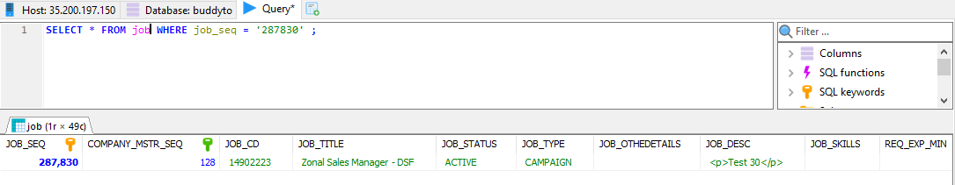

1. Candidate Details →

**Query :**

SELECT candidate_seq, user_profile_seq, first_name, last_name FROM candidate WHERE first_name = 'Kirtee' ;

**Output:**

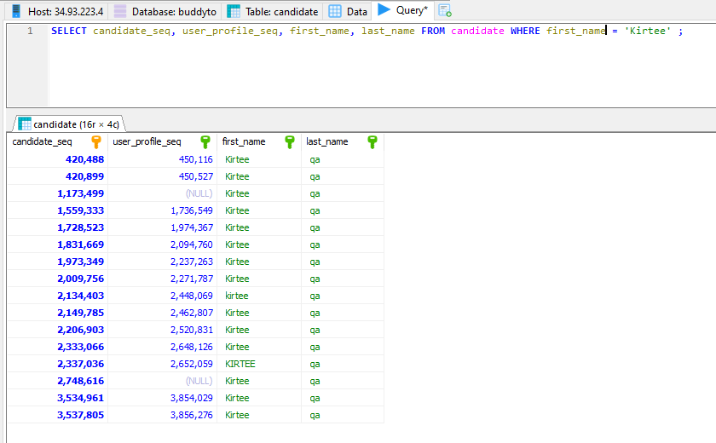

1. CP →

**Query :**

SELECT * FROM cp_document_status_mstr o

JOIN cp_document_request a ON a.DOCUMENT_STATUS_MSTR_SEQ = o.DOCUMENT_STATUS_MSTR_SEQ

WHERE a.EMPL_REFRL_SEQ =

(SELECT e.empl_refrl_seq

FROM empl_refrl e

WHERE RIPPLEHIRE_SEQ = "RH8233518");

**Output:**

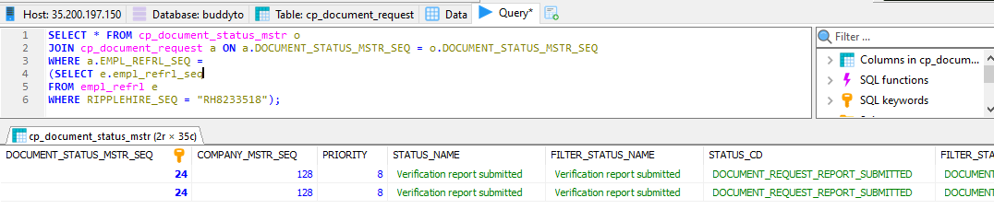

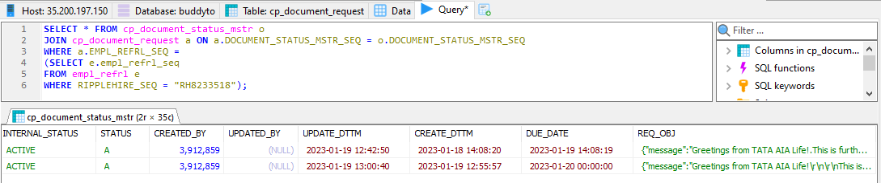

1. Offer (all related data) →

**Query :**

SELECT * FROM offer o

JOIN applicant_offer a ON a.OFFER_SEQ = o.OFFER_SEQ

WHERE a.EMPL_REFRL_SEQ =

(SELECT e.empl_refrl_seq

FROM empl_refrl e

WHERE RIPPLEHIRE_SEQ = "RH8233518");

**Output:**

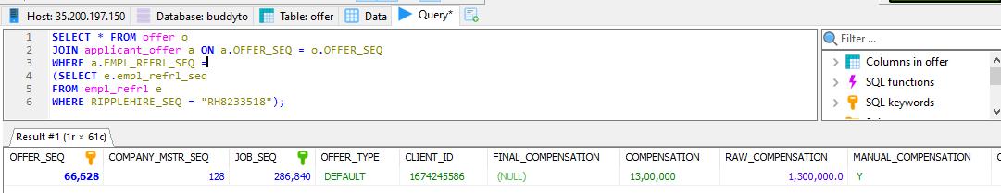

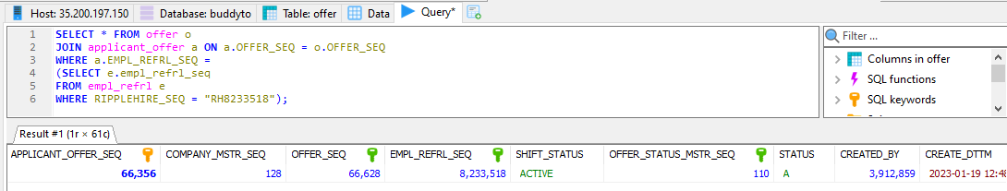

1. Employee related data →

**Query :** SELECT * FROM employee_mstr WHERE user_profile_seq = '3985852' ;

**Output:**

